**Personal Directory**

**User Guide**

By: Danny Cheng

Contents

Main Menu. . . . . . . . . . . . . . . . . . . . . . . . . . . . . . . . . . . . . . . . . . . . . . . . . . .2

Search for people . . . . . . . . . . . . . . . . . . . . . . . . . . . . . . . . . . . . . . . . . . . . .3

Add people. . . . . . . . . . . . . . . . . . . . . . . . . . . . . . . . . . . . . . . . . . . . . . . . . . .4

Delete people. . . . . . . . . . . . . . . . . . . . . . . . . . . . . . . . . . . . . . . . . . . . . . . . .5

Modify people . . . . . . . . . . . . . . . . . . . . . . . . . . . . . . . . . . . . . . . . . . . . . . . .6

Generate/View Database/Help/Save and Exit. . . . . . . . . . . . . . . . . . . . . .7

# Main Menu

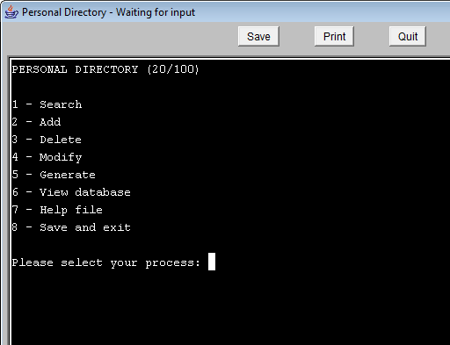

Select which method you would like to run.

1. Search allows user to search for a person
2. Add allows user to add a person
3. Delete allows user to delete a person
4. Modify allows user to modify a person
5. Generate allows user to generate people
6. Displays the current person database
7. Help file opens up a help file in a separate window
8. Save and exit saves all changes and exits the program.

Enter the number corresponding to the method you would like to run.

# Search for person

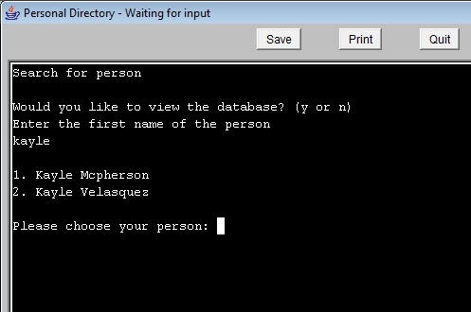

This method allows the user to search for a person in the array. Simply enter the person's first name, case-insensitive, and if they exist, their information will be displayed on screen. If the person can't be found, the program will ask the user if they would like to search again. If there are multiple people that share the person's first name, then the program will ask the user to choose from a list that includes last names and then display their information.

# Add

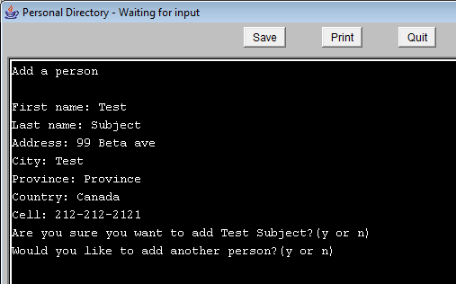

This method allows the user to add a person to the array. Simply enter the specified parameters and their information will be then saved to the array with proper capitalization. The program will then ask the user to confirm their addition and ask if they would like to add another person.

# Delete

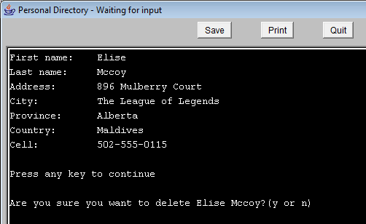

This method will allow the user to delete a person from the array. First the user must search for the person. The steps are identical to using the search method so if there are any issues please refer to that. The program will then ask the user to confirm their deletion and ask if they would like to delete another person.

# Modify

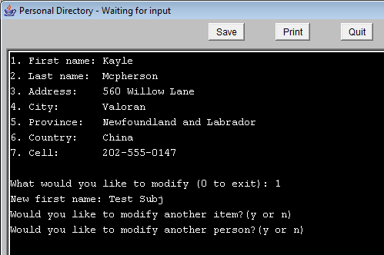

This method will allow the user to modify a person from the array. First the user must search for the person. The steps are identical to using the search method so if there are any issues please refer to that. The program will then ask which parameter the user would like to modify. If the user decides to not modify anything, they can enter 0 to exit. The program will then ask the user to confirm their modification and ask if they would like to modify another parameter. It will then ask the user if they would like to modify another person.

# Generate

This method will allow the user to generate people. The method will ask how many people they would like to generate and then generate them with random parameters.

# View database

This method will allow the user to view each person currently existing in the array in a nice format. The user can also go back a page by pressing the ‘a’ key.

# Personal Directory Help File

This method will open up a help file in a new window.

# Save and exit

This method will write each person currently in the array to the specified output file (directory.txt by default) and then exit the program completely.

## Y or N

When prompted with (y or n), simply enter y for yes and n for no.